Father of all, we pray to you for
those we love,
but see no longer....."

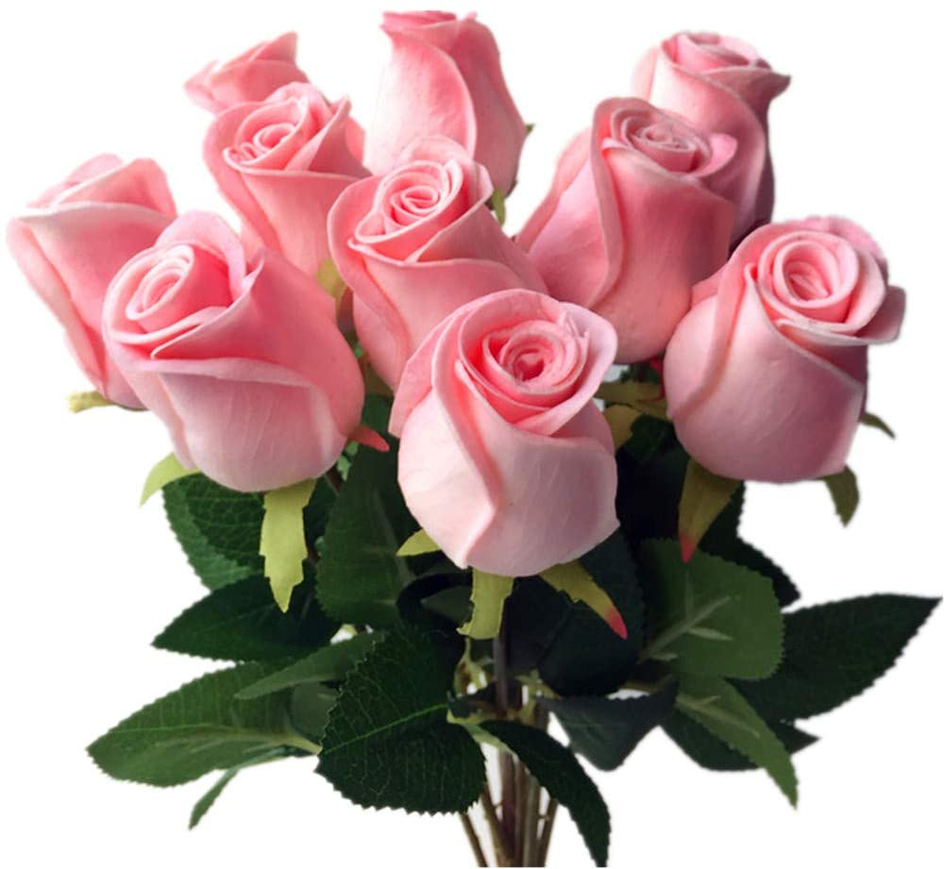

St. Francis of Assisi Episcopal Church
Wilsonville, Oregon

Sunday, June 6, 2021

St. Francis of Assisi Episcopal Church is blessed with two lovely memorial gardens ~ the Tower Garden and the East Memorial Garden. The people at rest here will always be members of our church family.

Avery..
Stephen Rosser..1955
Addie M. “MiMi” Cooke..1975
Wm. Howard King..1984
Catherine Beggs..1986
David Lathrop..1986
Robert Beggs..1987
Martha Findley..1987
Suzanne Graham..1987
Elizabeth A. Johnson..1988
Proctor Moore..1988
Douglas Graham..1989
Howard VanWinkle..1989
George Tuckey..1990
William Feasley..1991
Cecil Hobbs..1991
Barbara Johnsrud..1991
William Lehman..1991
Pryor Adskim..1992
Gerald Arrington..1992
Ragnar Giske..1992
Russell Johnsrud..1992
Barbara Montfort..1992
Bette Souther..1992
Buddy Young..1992
Fred Joehnke..1993
Lora Kelley..1993
Lee Schouboe, Jr..1993
Barbara Reynolds..1994
Donald Allen..1995
Margaret Josephson..1995
Kathleen Wisdom..1995
Hague Callister..1996
Alice Greve..1996
Karl Greve..1996
Josephine Lehman..1996
John MacDonald..1996
Hallie Moore..1996
Lois Parker..1996
Myla Schulte..1996
Paul Findley..1997
Lyle Omdahl..1997
Jay Schack..1997
Robert White..1997
H. R. “Joe” Josephson..1998
Jeanne Marston..1998
Margaret Whitelaw..1998
Douglas R. Courson..1999
Richard A. Rawlinson..1999
Margaret Taft..1999
Kathy Adskim..2000
John Chinnock..2000
Mildred R. Dierdorff..2000
MaryJo Olsen..2000
Anthony Petrotta, Sr..2000
Katheryn Utermohlen..2000
Dorthy J. Fly..2001
Jeffery Graham..2001
Earl Lathrop..2001
Margaret Lathrop..2001
Marguerite Scott..2001
Joseph Utermohlen..2001
The Rt. Rev. Hal Gross..2002
Martha Gunderson..2002
David Lister..2002
Grant J. Chittenden..2003
Edwin F. Gunderson..2003
LaVera M. “Kay” Lister..2003
Paul Sorensen..2003
Samuel Williams..2003
Evelyn “Billie” Gross..2004
Jean A. Holsinger..2004
Caralee Longwood..2004
Richard A. Montfort..2004
Alberta E. Smith..2004
Verne H. Dierdorff..2005
Sharon “Sheri” Garmon..2005
Louise D. Rawlinson..2005
Katharine V. “Cookie” King..2006
Dorothy D. Callister..2007
Ruth A. Chinnock..2007
Emily Cummins..2007
Gail H. Rosser..2007
Lewis E. Rosser..2007
Marjorie M. White..2007
Charles J. Fly..2008
Martin N. Kelley..2008
Kathleen Mary Sorensen..2008
Virginia VanWinkle..2008
Charles Allis..2009
Phyllis Anita Bardo..2009
Bobbi Duffy..2009
Colin Harwood..2009
James Edward Jenks..2009
Dorthy W. Klein..2009
Dagny C. Schack..2009
Herman “Dutch” Schneider..2009
Irene R. Schouboe..2009
Russel E. Klein..2010
Ruth Joehnke-Mitchell..2010
Harry Richard Murray..2010
Joanne Smith Omdahl..2010
Patricia K. Swan..2010
James W. Taft..2010
Edith Terrill..2010
John Wysock..2010
Mitchell George Dewey..2011
Anna N. Giske..2011
Allan Marston..2011
Vivian Day Seymour..2011
Clifford T. Stewart..2011
Jean Florence Cogger..2012
Margaret R. Edwards..2012
Claire M. Gray..2012
Eleanor M. Stewart..2012
Marilyn W. Arrington..2013
Eleanor I. Prince..2013
Oliver Gordon Seymour..2013
Robert G. Swan..2013
Gwendolyn E. Thompson..2013
Donald F. Cameron..2014
Lorraine Blanch Chittenden..2014
Jean Connolly..2014
Richard Anthony O’Heren..2014
George Dewey..2015
Darlene Nancy Hall..2015
Christopher Scott Miller..2015
Bruce Murray Yeats..2015
Debbi Plumleigh..2016
Jeddie Rea Tuckey..2016
Rev. John A. Bruce..2017
Fr. Thomas Cummins..2017
Dale Eugene Rushton..2017
Norman Weekly..2017
Fr. Douglas Woodridge..2017
Robert L. Foote..2018
Virginia MacDonald..2018
Gretchen A. McKenzie..2018
Suzanne Stewart..2018
Carl Webb..2018
Sheila Webb..2018
Kathleen Wisdom-Winthers..2018
Lusanne Wisecaver..2018
Fredrick D. Canning..2019

Joe Connolly..2019
George R. Scrugham..2019
Patricia A/ Simmons..2019
Arlene Maher Weekly..2019
Thomas S. Councell..2020
William Hammersley..2020
Gary M. Kuykendal..2020
Ronald Lehl..2020
John M. Prince..2020
Dorothy M. Gray..2021

Harpist: Barbara Cabot - Sacred Flight

